OUR UDDER SCORING SYSTEM
To ensure our herd does provide optimum nutrition to their kids as well as pass along desirable traits to future does, we evaluate each doe on numerous qualities, including udder characteristics. The udder score helps us determine which does to keep and which does require culling to maintain a healthy, strong and high quality herd, year after year. We understand and recognize that as does age and raise kids, their udder quality does change; therefore, we score each doe at kidding. And as an extra measure to select high quality herd-sires, herd-sire dams have multi-year records of good udder performance under our conditions.
5 | Ideal udder, capacious, wide attachments, good support, two small, cylindrical teats. | 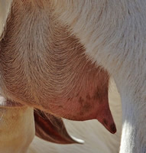 | 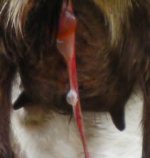
4 | Still a good udder, but not ideal. Common for older does that scored 5 in their early years. | 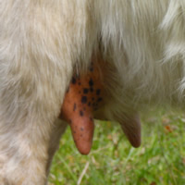 | 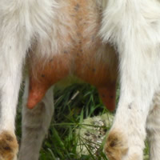
3 | Minimum acceptable udder, might be a little saggy, or have larger, more conical teats – however, kids are still able to suck & no intervention is required. Can stay in the herd but shouldn’t be used to produce herdsires. | 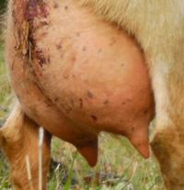 | 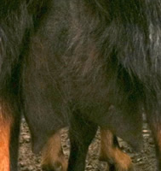
2 | Moderately pendulous or under-developed udder, or may have split, cluster, fish, or enlarged teats – but not bad enough to require intervention. Will be removed from our production herd. | 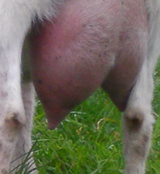 | 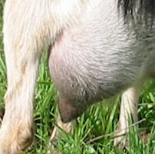
1 | Seriously pendulous or under-developed udder, or split, cluster, fish, or blown teats that required intervention, or obviously will upon the next kidding. Must be culled. | 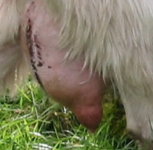 | 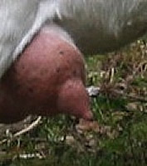

Pictures and udder description provided by Lookout Point Ranch.
